深 圳 大 学 实 验 报 告

课程名称： 数据库系统

实验项目名称： Basic SQL command LAB

学院： Computer Science and Software Engineering

专业： __计算机科学与技术（国际班）________

指导教师： Basker George

报告人：_ 吴嘉楷 _ 学号：_2022150168_ 班级：_ 国际班_ _

实验时间： 04th September 2023

实验报告提交时间： October 2023

教务部制
实验目的与要求：(Purpose of Experiment purpose and Requirements)
* Please show all work for these problems.
Just writing down the answer will not get full credit.

SQL的DDL语言和单表查询

Note: create a Table EMP and DEPT with all required constraints both Integrity and Referential Integrity Constraint.

EMP Table:
EMPNO | PRIMARY KEY NOT NULL  IF PRIMARY KEY MODIFED THEN CHILD MUST BE UPDATED | NUMBER(4)
ENAME | NOT NULL | VARCHAR2(10)
JOB | NOT NULL | VARCHAR2(9)
MGR | REFERENCES EMP(EMPNO) | NUMBER(4)
HIREDATE |  | DATE
SAL | NOT NULL  AND MORE THAN 5000 | NUMBER(7,2)
COMM |  | NUMBER(7,2)
DEPTNO | REFERENCES DEPT TABLE  DEFAULT 10 | NUMBER(2)

DEPT TABLE:

DEPTNO | PRIMARY KEY NOT NULL  DON’T ALLOW PRIMARY KEY TO BE MODIFIED IF CHILD RECORD EXIST | NUMBER(2)
DNAME |  | CHAR(10)
LOC |  | CHAR(10)

INSERT TUPLES FOR EMP TABLE:

EMPNO | ENAME | JOB | MGR | HIREDATE | SAL | COMM | DEPTNO
7369 | SMITH | CLERK | 7902 | 17-DEC-90 | 13750 | NULL | 20
7499 | ALLEN | SALESMAN | 7698 | 20-FEB-89 | 19000 | 6400 | 30
7521 | WARD | SALESMAN | 7698 | 22-FEB-93 | 18500 | 4250 | 30
7566 | JONES | MANAGER | 7839 | 02-APR-89 | 26850 |  | 20
7654 | MARTIN | SALESMAN | 7698 | 28-SEP-97 | 15675 | 3500 | 30
7698 | BLAKE | MANAGER | 7839 | 01-MAY-90 | 24000 |  | 30
7782 | CLARK | MANAGER | 7839 | 09-JUN-88 | 27500 |  | 10
7788 | SCOTT | ANALYST | 7566 | 19-APR-87 | 19500 |  | 20
7839 | KING | PRESIDENT |  | 17-NOV-83 | 82500 |  | 10
7844 | TURNER | SALESMAN | 7698 | 08-SEP-92 | 18500 | 6250 | 30
7876 | ADAMS | CLERK | 7788 | 23-MAY-96 | 11900 |  | 20
7900 | JAMES | CLERK | 7698 | 03-DEC-95 | 12500 |  | 30
7902 | FORD | ANALYST | 7566 | 03-DEC-91 | 21500 |  | 20
7934 | MILLER | CLERK | 7782 | 23-JAN-95 | 13250 |  | 10
EMPNO | ENAME | JOB | MGR | HIREDATE | SAL | COMM | DEPTNO
3258 | GREEN | SALESMAN | 4422 | 24-JUL-95 | 18500 | 2750 | 50
4422 | STEVENS | MANAGER | 7839 | 14-JAN-94 | 24750 |  | 50
6548 | BARNES | CLERK | 4422 | 16-JAN-95 | 11950 |  | 50
7500 | CAMPBELL | ANALYST | 7566 | 30-OCT-92 | 24500 | 0 | 40

INSERT TUPLES FOR DEPT TABLE:

DEPTNO | DNAME | LOC
10 | ACCOUNTING | LONDON
30 | SALES | LIVERPOOL
40 | OPERATIONS | STAFFORD
50 | MARKETING | LUTON
20 | RESEARCH | PRESTON

- List all information about the employees.
Select * from emp;
2 List all information about the departments
Select * from dept;
3 List only the following information from the EMP table ( Employee name, employee number, salary, department number)
Select ENAME,EMPNO,SAL,DEPTNO from emp;
4 List details of employees in departments 10 and 30.
Select * from emp where DEPTNO in (10,30);
5 List all the jobs in the EMP table eliminating duplicates.
Select distinct JOB from emp;
6. What are the names of the employees who earn less than £20,000?
Select ENAME from emp where SAL<20000;
7. What is the name, job title and employee number of the person in department 20 who earns more than £25000?
Select ENAME,JOB,EMPNO from emp where DEPTNO=20 and SAL>25000;
8. Find all employees whose job is either Clerk or Salesman.
Select * from emp where trim(JOB) in('CLERK','SALESMAN');
9. Find any Clerk who is not in department 10.
Select * from emp where trim(JOB) = 'CLERK' and DEPTNO != 10;
10. Find everyone whose job is Salesman and all the Analysts in department 20.
Select * from emp where trim(JOB)='SALESMAN' or trim(JOB)='ANALYST' and DEPTNO=20;
11. Find all the employees who earn between £15,000 and £20,000.
Show the employee name, department and salary.
Select ENAME,DEPTNO,SAL from emp where SAL between 15000 and 20000;
12 Find the name of the President.
Select ENAME from emp where trim(JOB)='PRESIDENT';
13 Find all the employees whose last names end with S
Select * from emp where trim(ENAME) like '%S';
14 List the employees whose names have TH or LL in them
Select * from emp where trim(ENAME) like '%TH%' or trim(ENAME) like '%LL%';
15 List only those employees who receive commission.
Select * from emp where COMM!=0;
16 Find the name, job, salary, hiredate, and department number of all employees by alphabetical order of name.
Select ENAME,JOB,SAL,HIREDATE,DEPTNO from emp order by ENAME;
17. Find the name, job, salary, hiredate and department number of all employees in ascending order by their salaries.
Select ENAME,JOB,SAL,HIREDATE,DEPTNO from emp order by SAL;
18. List all salesmen in descending order by commission divided by their salary.
Select * from emp where trim(JOB)='SALESMAN' order by COMM/SAL desc ;
19. Order employees in department 30 who receive commision, in ascending order by commission
Select * from emp where DEPTNO=30 and COMM!=0 order by COMM;
20 Find the names, jobs, salaries and commissions of all employees who do not have managers.
Select ENAME,JOB,SAL,COMM from emp where MGR=0;
- Find all the salesmen in department 30 who have a salary greater than or equal to £18000.
Select * from emp where trim(JOB)='SALESMAN' and DEPTNO=30 and SAL>=18000;
- Find the employees who were hired before 01-Jan-1998 and have salary above 5000 or below 1000.
Select * from emp
where HIREDATE<'1998-01-01' and SAL>5000 or SAL < 1000;
- What is the command to add primary key constraint to EMPNO
alter table emp
add constraint pk_emp primary key (EMPNO);
- What is the command to add a new column EMP_family_name to existing EMP table
alter table emp
add EMP_family_name varchar(30);
- How to drop primary key constraint for EMPNO
alter table emp
drop constraint pk_emp;
- rename EMP table to EMPLOYEE
alter table emp
rename to employee;
- rename EMPLOYEE back to EMP
alter table employee
rename to emp;
- What is the SQL command to remove column EMP_family_name from EMP table
alter table emp
drop column EMP_family_name;
- What is the SQL command to copy emp table to employee table
If employee table exists, insert into employee select *from emp;
Else, create table employee select *from emp;
- What is the SQL command to drop employee table
drop table employee;
- What is the SQL command to find the employee whose commission is NULL
select *from emp where COMM = NULL;
实验过程及内容：(Methods and steps)
.
Use PHPMYADMIN/WAMP Server to complete the exercise
- login mysql through phpmyadmin
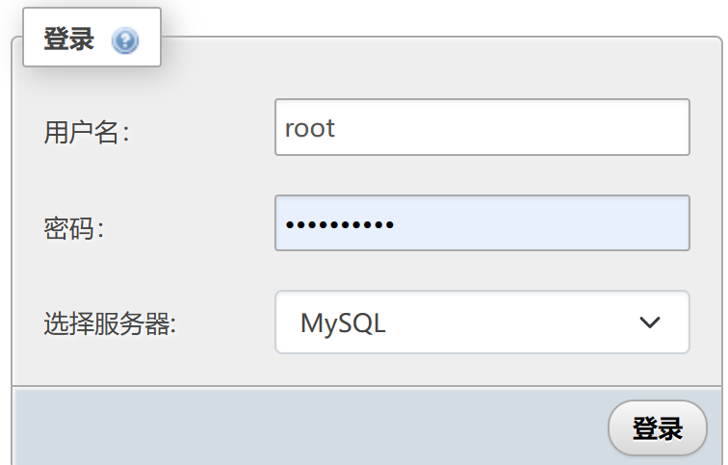
- create a database “emp_dept”

- create a table “dept”
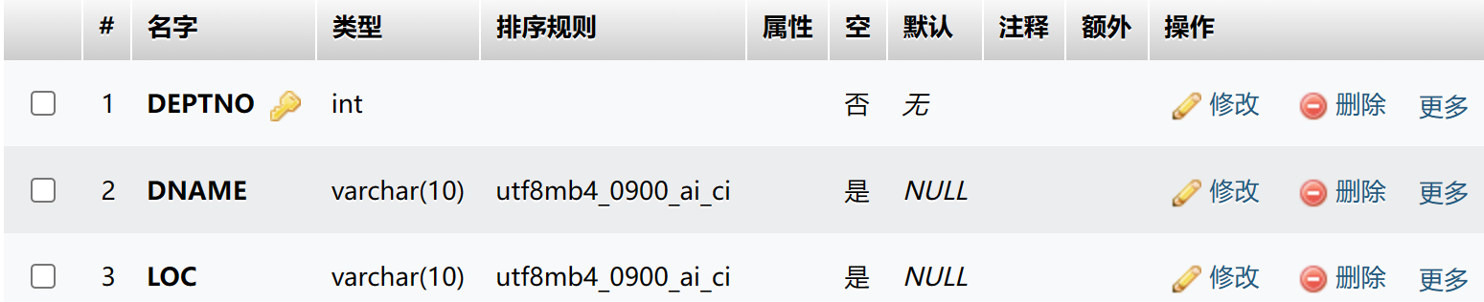
- add constraints to DEPTNO
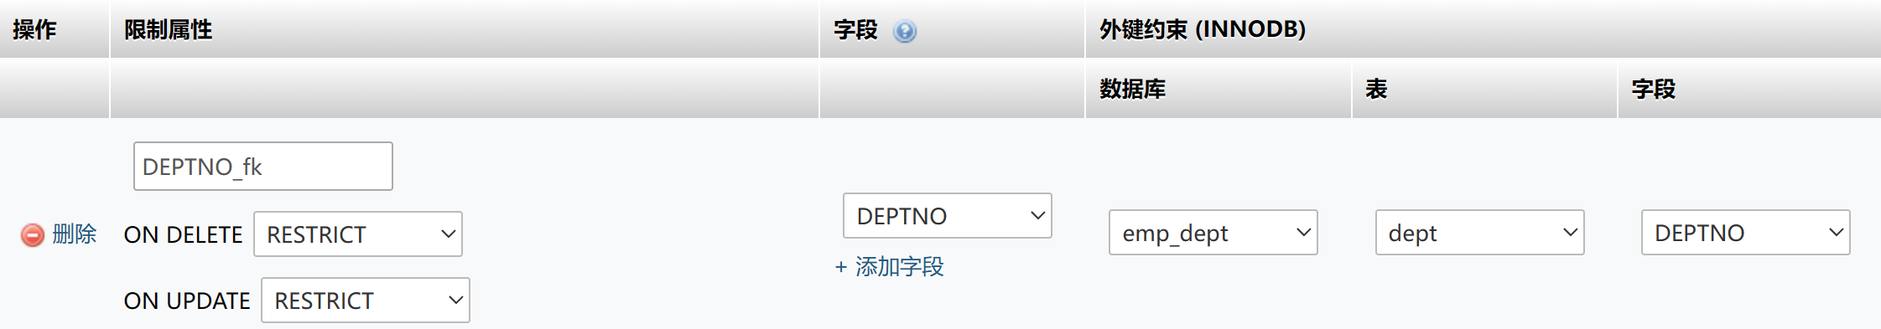
- insert datas for dept table
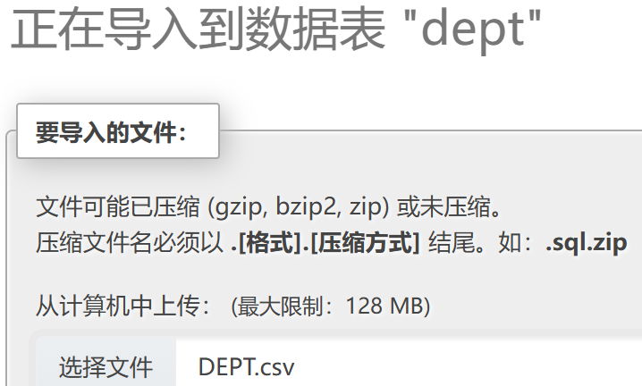
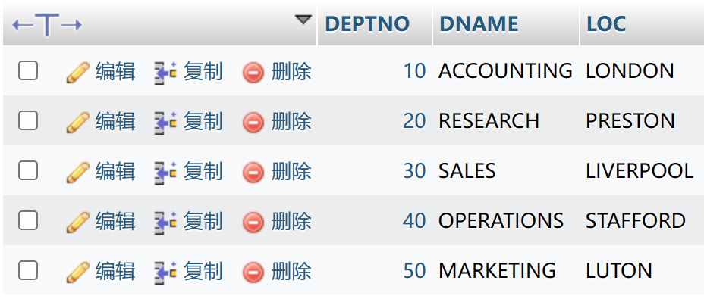
- create a table “emp”
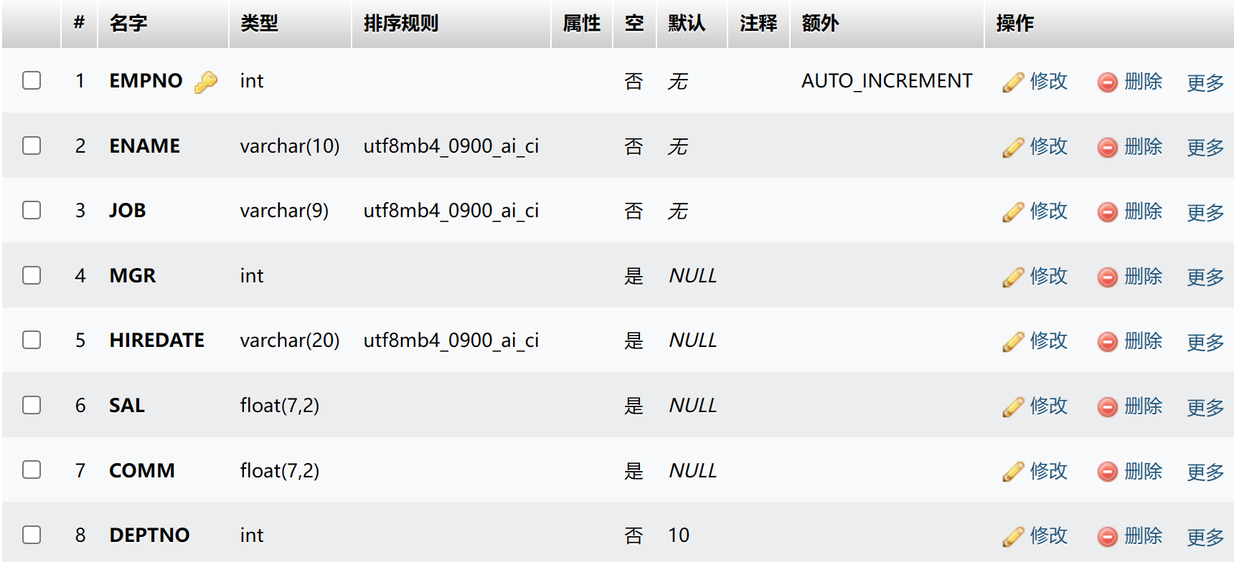
- insert datas for emp table
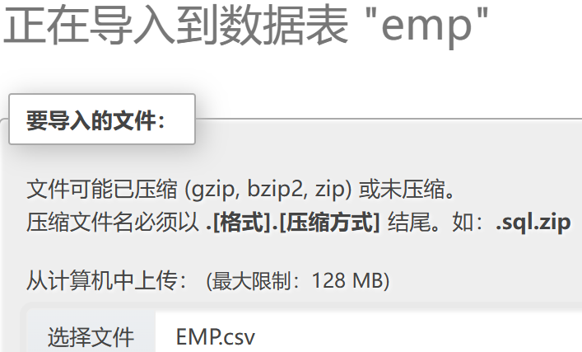
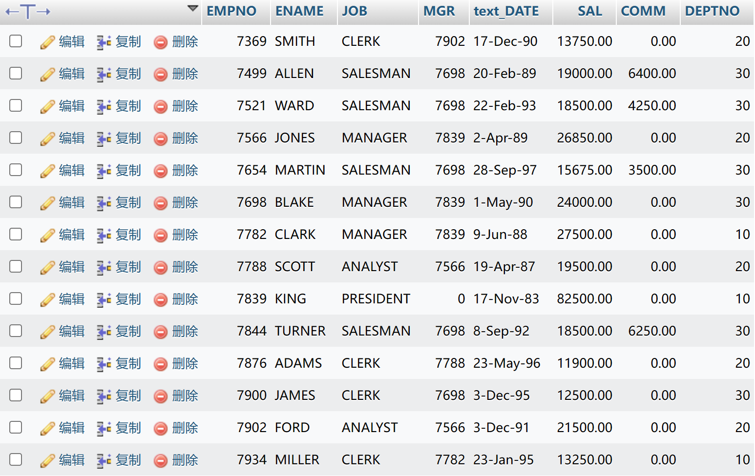
8、add constraints to DEPTNO
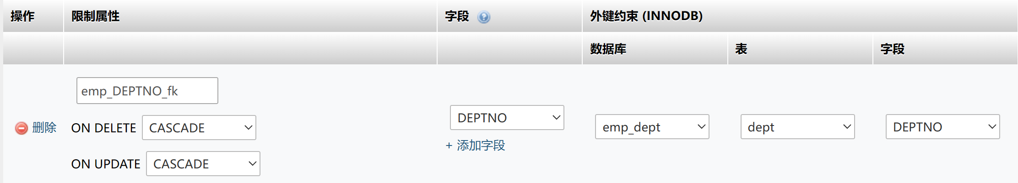
9、add constraints to SAL
10、add one column named HIREDATE after text_DATE
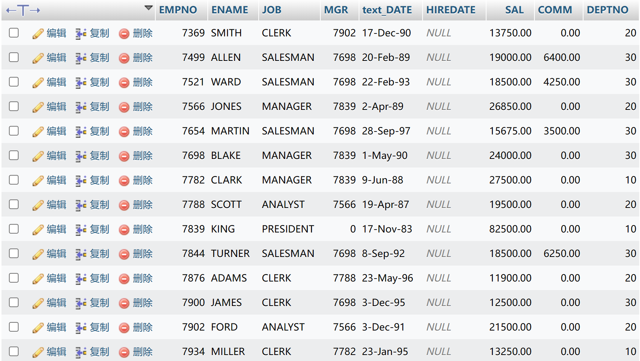
- execute the SQL below
- delete the column named text_DATE
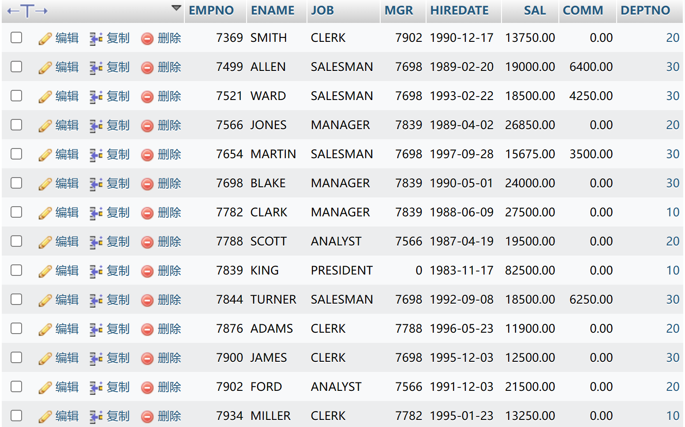

数据处理分析：(Experiment process and content)

Because a straight import will result in all my dates showing up as '0000-00-00',
I create a VARCHAR column named“ text_DATE” at first,then add the DATE column named”HIREDATE” after “text_DATE”

After that, I execute the SQL command “ UPDATE emp SET HIREDATE = STR_TO_DATE(text_DATE,’%d-%b-%Y’); ”
At last, delete the column named “text_DATE”.
As a result, the table shows the datas as follow.

深圳大学学生实验报告用纸

指导教师批阅意见：
The following problems was identified from the students answer:

成绩评定：

Final Grade of Student is:

指导教师签字：Basker George
2023年10月 05日
备注：
注：1、报告内的项目或内容设置，可根据实际情况加以调整和补充。
2、教师批改学生实验报告时间应在学生提交实验报告时间后10日内。

